

 Hamil Home Construction

**Drew - Sam - Tyler**

**Business Needs**

Business Need/Case:

Hamil Home Construction's recent acquisition of a significant parcel of land zoned for residential housing marks an exciting opportunity to expand our portfolio and contribute to the community's housing needs. We envision transforming this land into a thriving single-family housing subdivision, starting with the construction of a stunning "spec" home that showcases our craftsmanship and attention to detail.

 However, embarking on this venture entails a blend of excitement and challenge. While we see tremendous potential in this project, we're also aware of the complexities and risks involved. Managing every aspect of development, from coordinating a diverse team of professionals including project managers, electricians, plumbers, and landscapers, to ensuring compliance with budget and time constraints, is no small feat.

 Our commitment to excellence is unwavering, but we must also navigate the practical realities of the construction process. With a budget of $380,000 and a tight timeframe of 12 working periods, every decision counts. We understand the importance of staying within these parameters to deliver not just a home, but an investment that exceeds expectations.

 Additionally, we're mindful of the looming snow season, which adds urgency to our timeline. As we strive to complete the project within approximately five months, we're acutely aware of the potential weather-related disruptions. Our goal is not just to meet deadlines, but to do so with quality and craftsmanship that stand the test of time.

With a blend of expertise, dedication, and a human-centered approach, we are poised to turn this vision into reality, delivering not just homes, but dreams fulfilled for our clients and the community.

**Objective (SMART)**

Complete the construction of new residential buildings for single families within the 12 work period timeframe and a budget of $380,000, ensuring quality, efficiency, and profitability.

**Mission Statement**

"Our mission is to craft homes that reflect our clients' dreams and enrich lives. We prioritize sustainability, quality craftsmanship, and innovative design within set budgets and timelines. Through attentive service, we aim to foster joy and community connections in every home, ensuring Hamil Home Construction remains cost-effective and delivers value to our residents."

**Scope Overview**

Hamil Home Construction has a plot of land for residential housing and plan to develop a subdivision for families. Once this property is developed,

**Deliverables**

Completed "spec" home showcasing craftsmanship and quality.

Developed infrastructure including foundation, utilities, and landscaping.

Compliance with building codes and regulations.

Timely completion of the project within the allotted timeframe of 12 work periods.

Delivery of high-quality residential buildings that meet or exceed customer expectations.

Stay within the budget of $380,000.

Produce accurate weekly reports.

**Risks/Constraints/Assumptions**

**Budget Overview**

The total initial budget for the project was $380,000.

The “Estimated Costs” for all labor during the project is $245,840.

The estimated budget for periods 1-4 is $107,800.

The actual cost so far for periods 1-4 amounts to $128,719, with additional expenses for training and unallocated resources totaling $22,985 for a total actual cost of $151,704.

Currently, the project is over our time period budget by $43,904.

With the remaining budget, there's approximately $228,296 left for the project.

These are the personnel we currently, or have previously employed:

**Project Managers:**

Nobuyuki Nakamura (Rate: $140, periods 1-4)

Ronald Olivo (Rate: $140, periods 1-4)

**Electricians:**

Leonard Rodenberg (Rate: $89, periods 1-3)

**Paving & Concrete**:

Raul Chavez (Rate: $85, periods 1-3)

**Plumbers:**

Carrie Cuthbert (Rate: $82, periods 1-3)

**Surveyors:**

Cody Wachtel (Rate: $72, periods 1-3)

Darryl Lindbloom (Rate: $72, periods 1-3)

**Rough Carpenters**:

Javier Narro (Rate: $57, period 4)

Huang Fu dugu (Rate: $56, period 4)

Ella Coston (Rate: $50, periods 1-4)

**Landscapers:**

Donald Menard (Rate: $50, period 2)

Kioko Saito (Rate: $50, period 2)

**Milestone Schedule**

**Site Preparation and Infrastructure Development (Periods 1-2)**

Period 1: Site Preparation and Initial Excavation (February 20, 2024 - February 26, 2024)

Period 2: Foundation Construction Progress (March 04, 2024 - March 15, 2024)

**Building Construction Commencement (Periods 3-6)**

Period 3: Framing Commencement (May 07, 2024 - May 28, 2024)

Period 4: Advancement in Building Structure (May 28, 2024 - June 26, 2024)

Period 5: Finalization of Building Frame (June 12, 2024 - June 28, 2024)

Period 6: Interior Finishing Preparation (June 28, 2024 - July 22, 2024)

**Interior and Exterior Finishing (Periods 7-10)**

Period 7: Interior Finishing Initiation (July 22, 2024 - August 05, 2024)

Period 8: Continued Interior Finishing (August 05, 2024 - August 15, 2024)

Period 9: Finalization of Interior Finishing (August 15, 2024 - August 22, 2024)

Period 10: Exterior Work and Final Touches Preparation (August 22, 2024 - September 03, 2024)

**Landscaping and Final Touches (Periods 11-12)**

Period 11: Exterior Finishing and Landscaping (September 03, 2024 - September 10, 2024)

Period 12: Final Touches and Completion (September 10, 2024 - September 20, 2024)

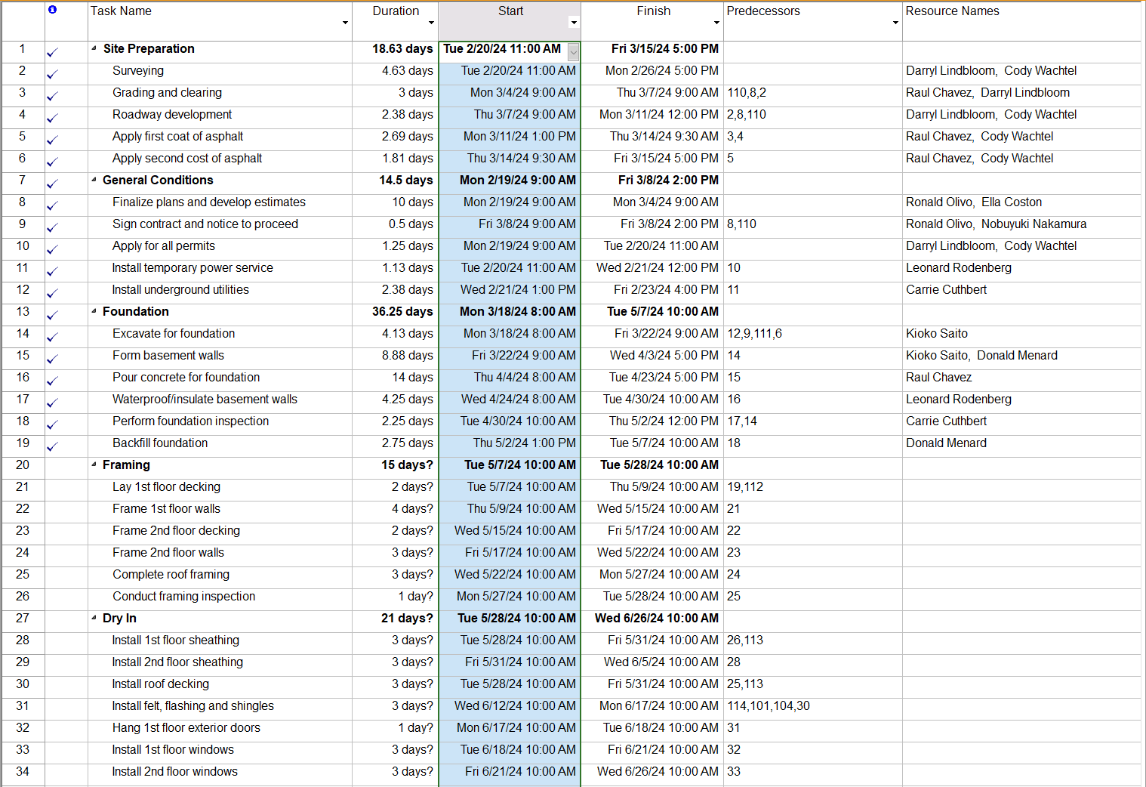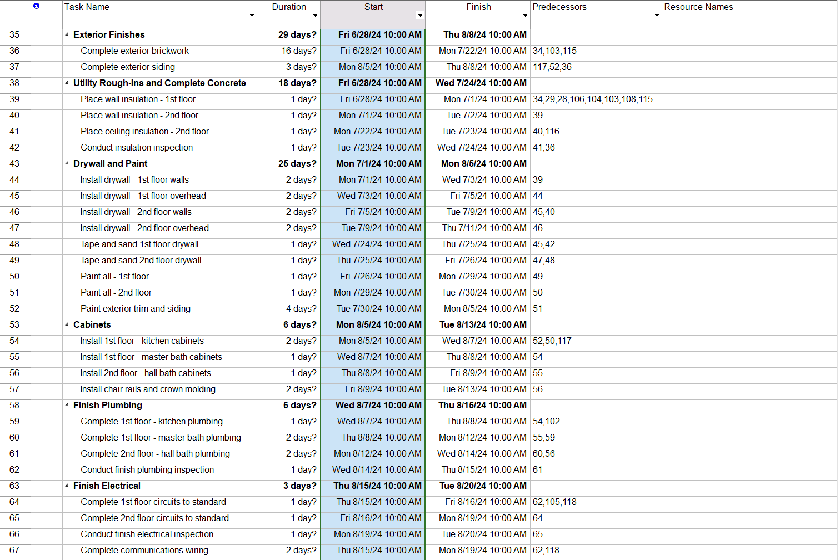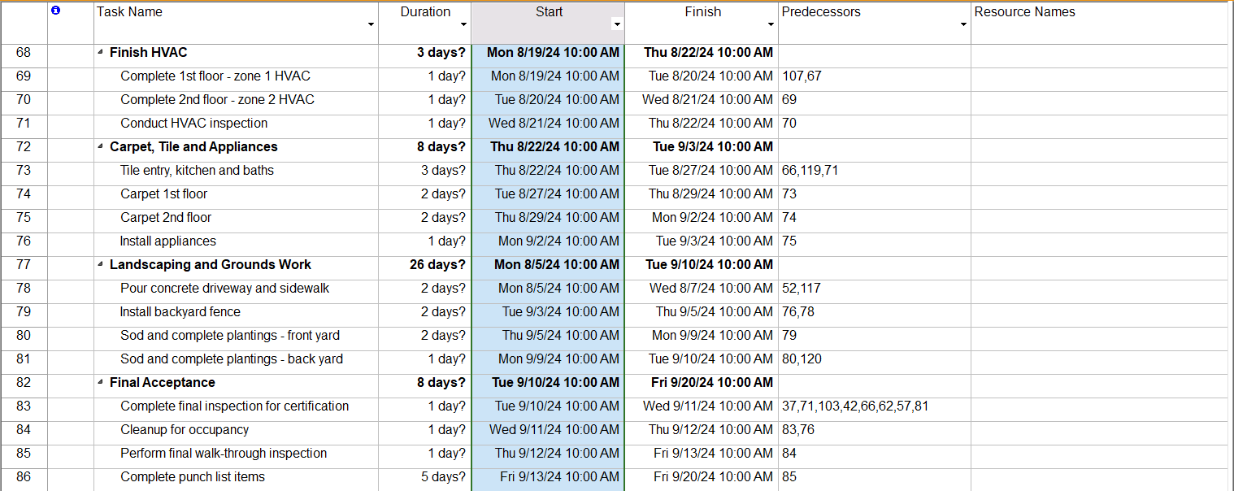

**Stakeholders**

|  |  |  |  |  |  |
| --- | --- | --- | --- | --- | --- |
| Project Name: Hamil Home Construction | | | Beginning Date: 02/19/24 | | |
| Project Manager: Tyler, Sam, Drew | | | Completion Date: 05/19/24 | | |
| Plan Owner: Hamil Construction | | | | | |
| Planning | | | | | |
| Project objective and key message points(high level):   * Build Single Family Home * Install Heating, Electrical, Plumbing, Carpeting, Drywall, Windows * Obtain all permits and contracts * Lay foundation, pour asphalt and concrete * Be cost-effective * Complete the project within 5 months/before the winter season | | | | | |
| Stakeholders-target audience:   * Tyler- Project Manager - 29 - text/call * Sam- Project Manager- age 19- text/call/email * Drew- Project Manager- Age 20- Text/call * Thea Hempel - Project Sponsor - Email updates once a week * Nobuyuki Nakamura- Sim Project Manager- Age 38- Rate $140- Call * Ronald Olivo- Sim Project Manager- Age 38- Rate $140- Call | | | | | |
| Outline | | | | | |
| Timeline  (date) | Team Member (responsible for communication) | Target (Audience) | Tool (medium for communication delivery) | Message Points | Status (done, ongoing, etc) |
| 2/19/24 | Sam, Drew, Tyler | Entire team | Meeting | Intros, project goals, expectations | Done |
| Weekly | Team 3 | Thea Hempel | Email/Zoom Call | Weekly updates | Ongoing |
| As Needed | Team 3 | Entire Team | Text/Call/Zoom | Any urgent updates | Ongoing |
| As Needed | Team 3 | Nobuyuki, Ronald | Call | Progress Updates, Coordination | Ongoing |

**Team Operating Principles**

Our team ground rules are straightforward but essential for our success. We agree to work together, ask questions, and seek help when needed. We'll be present and attentive during Zoom meetings, and if we can't make it, we'll inform our teammates. Each of us commits to doing our part and helping our team succeed. We understand the importance of effective communication and staying engaged with the group. Lastly, we'll communicate regularly about our progress and challenges. Together, we're dedicated to achieving our goals and delivering successful outcomes.

**Approval Signature: ________________________ Date: ____________**